Command Execute in Background/Foreground

1. Execute in Foreground

$ command

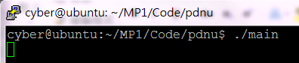

2. Execute in Background

$ command&

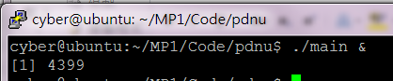

Reference:

<https://linuxize.com/post/how-to-run-linux-commands-in-background/>